Day 4 - Service Enumeration Lab Report

Student Name: Urooj Atif
Date: 14-September-2026
Target Machine: Metasploitable2
Attacker Machine: Kali Linux

1. OBJECTIVE

The objective of Service Enumeration is to identify running
services, OS version, and open ports on the target machine
to find potential security weaknesses.

2. LAB SETUP

- Attacker: Kali Linux - IP: 192.168.50.101
- Target: Metasploitable2 - IP: 192.168.56.102
- Tool Used: Nmap

3. PROCEDURE AND SCREENSHOTS

Step 1: IP Address Finding
First, we checked the IP addresses of both machines.
Kali Linux Ip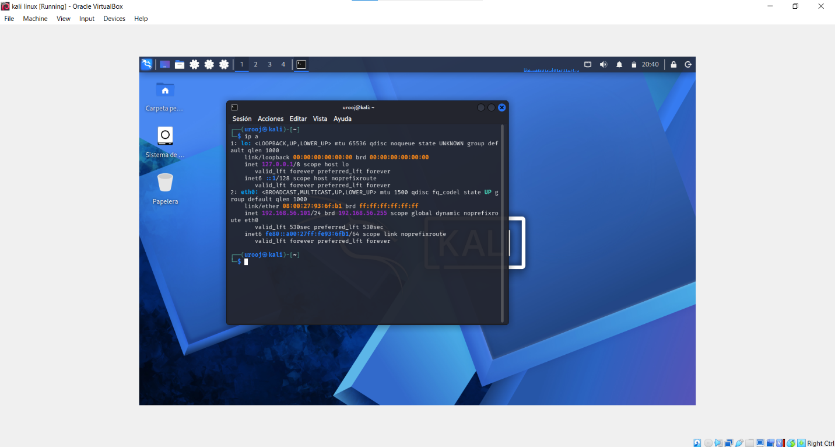
Metasploitable IP : 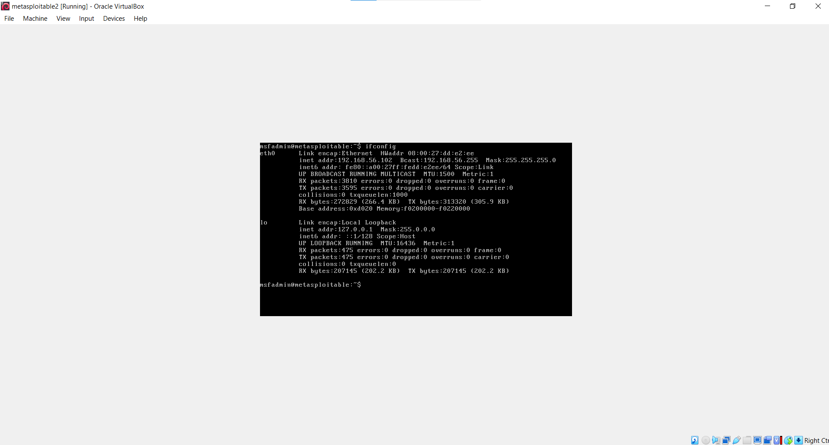

Step 2: Connectivity Test - Ping
We pinged Metasploitable from Kali to verify connectivity.
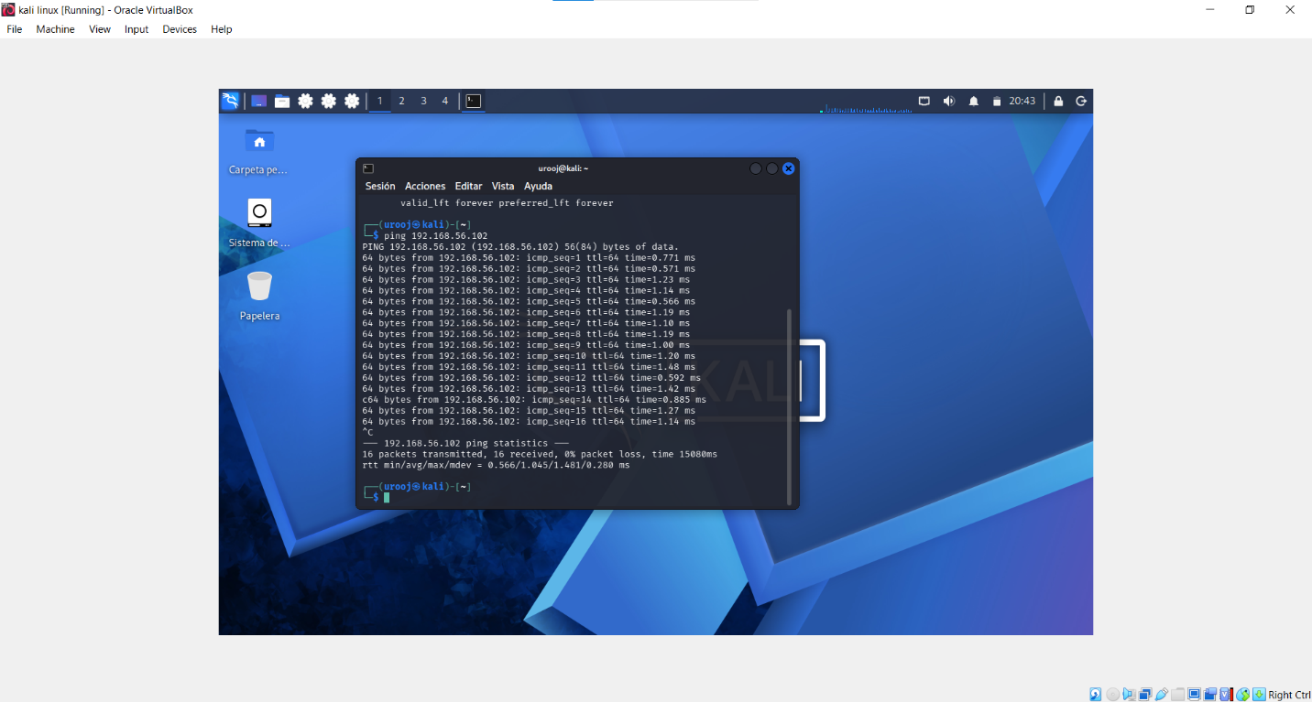

Step 3: Initial Service Scan
Command: nmap -sV -sC 192.168.56.102
Basic service enumeration was performed.
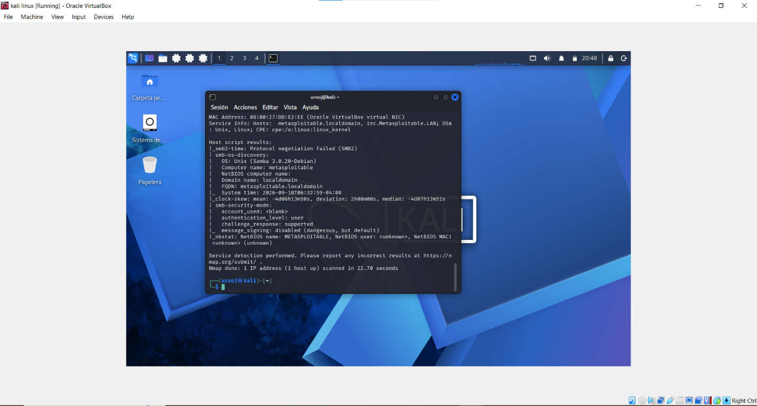

Step 4: Detailed Service Scan
Command: nmap -sV -sC -p- 192.168.56.102
This command was used to scan all 65535 ports.

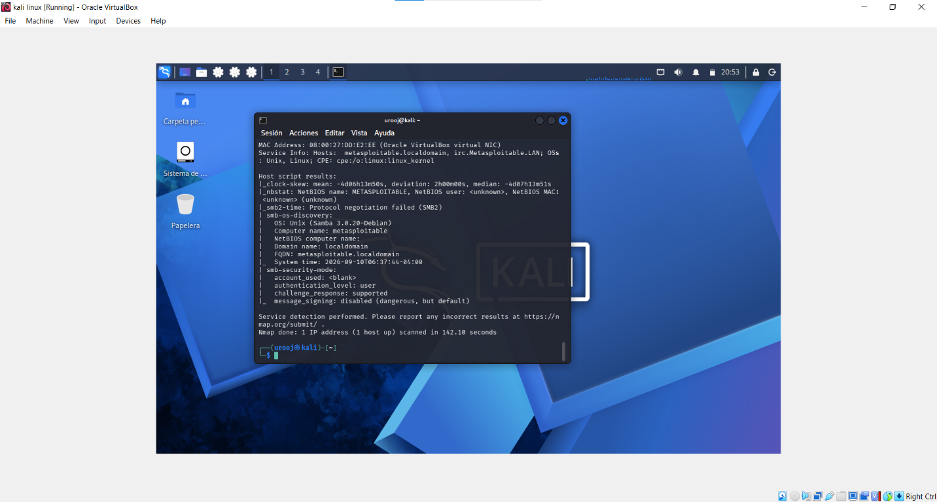
Step 5: Final Scan Result
After the scan completed, we obtained complete information
about the target machine.
[

4. ENUMERATION RESULTS TABLE

| Parameter | Value Found | Risk Level |
|--------------------|---------------------------------|------------|
| IP Address | 192.168.56.102 | - |
| Hostname | metasploitable.localdomain | Low |
| NetBIOS Name | METASPLOITABLE | Low |
| Operating System | Linux - Samba 3.0.20-Debian | Medium |
| SMB Version | 3.0.20-Debian | High |
| SMB Signing | Disabled | HIGH |
| MAC Address | 08:00:27:DD:E2:EE | - |
| Scan Duration | 142.10 seconds | - |

5. KEY FINDINGS

1. The target machine is running Linux OS with Samba 3.0.20 service.
2. Major Vulnerability: SMB message_signing is disabled.
This is dangerous and vulnerable to Man-in-the-Middle attacks.
3. Hostname metasploitable.localdomain was confirmed.

6. CONCLUSION

Through Service Enumeration, we successfully identified the
OS, hostname, and SMB service version of the Metasploitable machine.
The disabled SMB signing is a significant security issue that
can be fixed with proper secure configuration.

